Software Requirements Specification
For
JMS Self Service Tool
Version 1.0 approved
Prepared by Kaustubh Shah
SE2 Digital Service LLP
26/8/2020
Table of Contents
Table of Contents ii
Revision History ii
1. Introduction 1
1.1 Purpose 1
1.2 Intended Audience and Reading Suggestions 1
1.3 Product Scope 1
2. Product Overview 2
2.1 Product Perspective 2
2.2 Product Functions 2
2.3 User Classes and Characteristics 2
2.4 Software Interfaces 3
2.5 Communication Interfaces 3
3. Work Flow 4
3.1 User Interfaces 4
4. Evaluation Plan and Performance Metrics 8
4.1 Evaluation Plan 8
4.2 Performance Metrics 8

Revision History
Name | Date | Reason For Changes | Version

Introduction

Purpose
The purpose of this Application is to help the user to process cycle on a Single contract as well as multiple contracts on a single click.

Intended Audience and Reading Suggestions
This Document is intended for the developers, product configurators and testers who are going to interact/develop the JMS Tool application

Product Scope
All the associates can use this application for processing of the batch jobs by directly pushing requests on message queues.

This application will replace existing process where user brings up the server every time to process single contract through putty by placing messages to MQ.

Product Overview

Product Perspective
The users will be able to access this application using a URL, which will open a web page on web browser.

This application is based on the client-server architecture where the client sends the requests to the server and server responds back with a response.

This application is one page application which will interact with the server to push the messages on the queue and read the messages that are available on the queue.

Product Functions
The application will be in the form of web app/ website.

User can use the application for two functions:

- Cycle Processing
- API Request Processing

- Cycle Processing

In this function the users input the contract number and the date of contract and select the cycles which are required for the contract. These details will be saved in the form of XML Message and sent to the messaging queue

- API Processing

In this function the user can type the XML Message and send it to messaging queue.

Further functions of the applications are:

- User can view all the responses that are available in the queue.
- User can view the count of requests and responses that are present the queues
- User can purge both queues

User Classes and Characteristics
This application will be used by all the associates of the institution for the purpose of the batch jobs so privilege levels will be same for all the users.

Software Interfaces
Technology Stack | Component
Angular 1.5 | UI design
Java 8, Spring Boot | Backend technology & server
Apache ActiveMQ | Queue

The AngularJS Web Application will communicate with the Spring Boot Controller. The Spring Boot Controller will receive the messages from the ActiveMQ messaging queue via HTTP GET Method and will send this message to the AngularJS web application using HTTP POST method.

Communications Interfaces
The communication between the interfaces will be done using HTTP Methods. GET Method will be used for obtaining the message from interface to another and POST Method will be used for sending the message to the other interfaces.

Work Flow
  - User Interface Fields

- Static Fields

Field Name | Description
What you want to do? | - Drop Down Menu:  - Cycle Processing  - API Processing  - Mandatory Field
Environment Name | - Drop Down: Contains list of all available Environment.  - LCREREG  - LCDEV  - LCRELP01  - LCRELD2  - Mandatory Field

- Dynamic Fields:

When the field “What do you want to do?” is selected as “Cycle Processing”:

Field Name | Description
Contract No. | - TextBox  - Store Contract no. for which cycle needs to be processed.  - If leftblank thentreated as multiple cycle processing. (If empty set value to ‘*’)
Date | - Date Picker  - Mandatory Field  - Select the date for which cycle needs to be process.
Cycle Switches | - Check Box  - Contains List of all switches, which needs to process.  - At Least one switch needs to be selected.
Submit Request | - Button  - Validate all mandatory fields are populated by user.  - Validate at least on check box is selected in cycle switches list.  - Generate XML in below format.  <executeCycleCommand xmlns:ns2="http://lifecad.accenture.com">  <contractMask>4590000962</contractMask>  <statusList>%</statusList>  <cycleDate>20200107</cycleDate>  <checkpointFrequency>01</checkpointFrequency>  <batchId>-999</batchId>  <cycleSwitches>AU</cycleSwitches>  </executeCycleCommand>

When the field “What do you want to do?” is selected as “Cycle Processing”:

Field Name | Description
Enter Input Message | - Text Area  - Mandatory to provide xml.
Send Request | - Button  - Send entered message on request Queue
Show All Responses | - Button  - Fetch all the responses from response queue and display under Response label.
Count Total No of Request | - Button  - Count total no. of request, which are in request queue and display it in front of label ‘Total No. of message in request queue’.
Count Total No of Response | - Button  - Count total no. of request, which are in request queue and display it in front of label ‘Total No. of message in Response queue’.
Clear Request Queue | - Button  - Purge Request queue messages
Clear Response Queue | - Button  - Purge Request queue messages
Responses | - Table  - It is displayed only when the user hit on Show All Responses button.
Total No. of message in request queue | - Label  - It gets displayed only when user hit on button ‘Count Total No of Request’.
Total No. of message in Response queue | - Label  - It gets displayed only when user hit on button ‘Count Total No of Response.

3.2User Interfaces
    - Initial User Interface
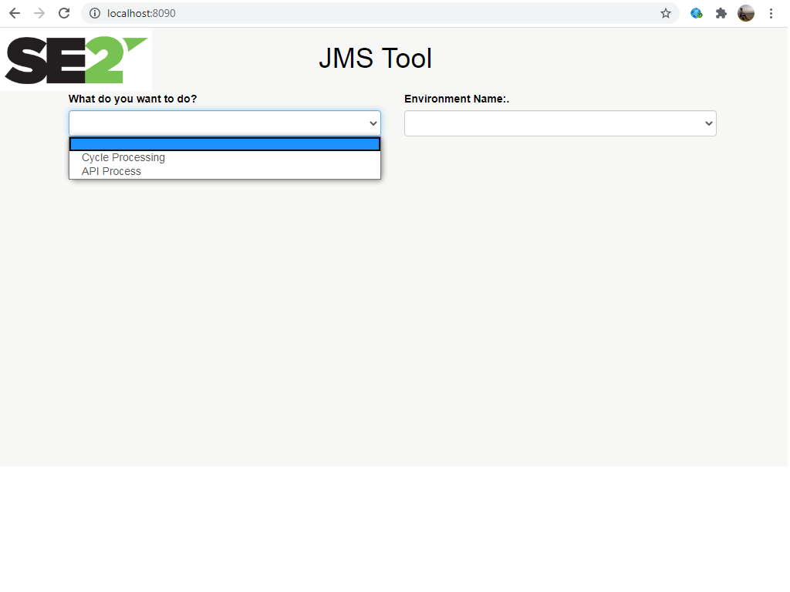

When the user accesses the URL, the user’s browser displays this page. Here the user can select from the two functions (Cycle Processing and API Process) that are seen in the dropdown menu of the field, “What do you want to do?”

    - User Interface when Cycle Processing is selected:

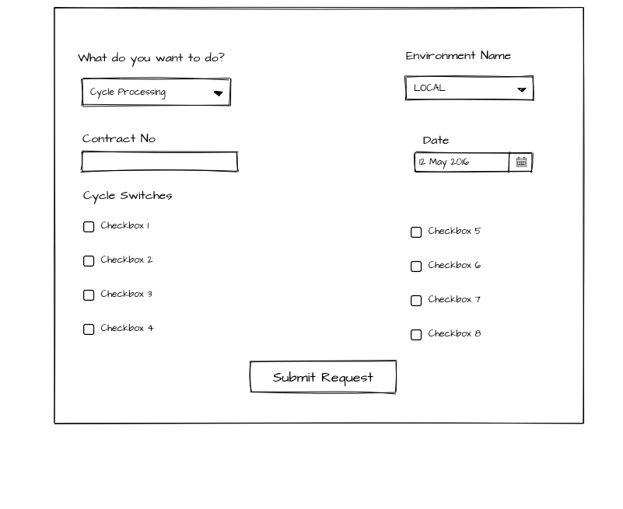

This is the User Interface when Cycle Processing is selected. At least one cycle should be selected on this interface and all the mandatory fields i.e. Environment Name and Date has to be filled in order to submit the request.

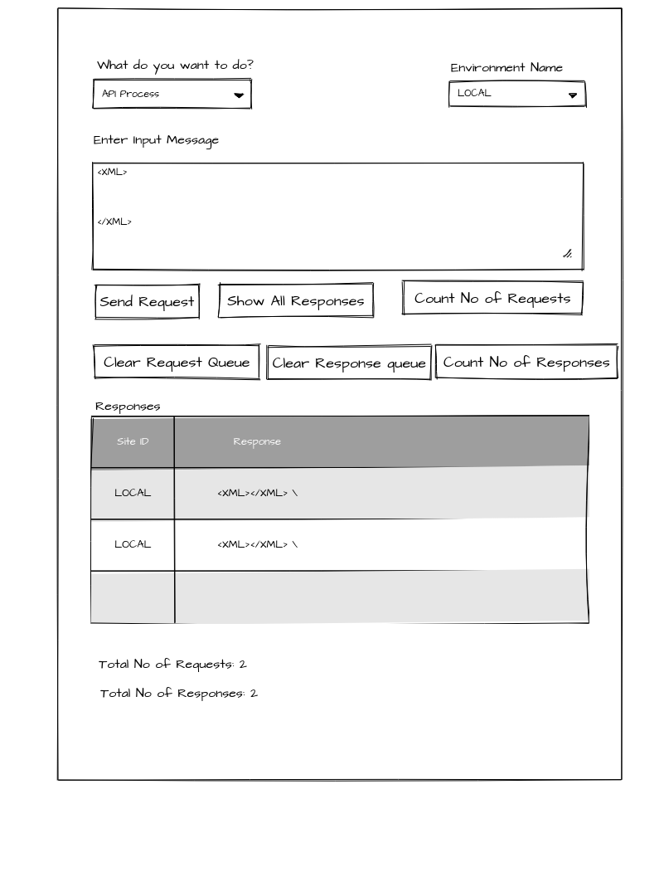
3.2.3. User Interface when API Process is selected

The User Interface should consist of a text area where user can input XML Message and submit the request to the messaging queue. The XML message can be submitted only if the mandatory fields i.e. Environment Name and XML Message are filled.

This interface will also consist of following buttons:
- Show All Requests : On clicking this button all the responses in the Response queue will be displayed in the form of table
- Count total No of Request: On clicking this button the total number of messages present in the Request queue will be displayed
- Count total No of Responses: On clicking this button the total number of messages present in the Response queue will be displayed
- Clear Request queue: On clicking this button the Request queue is purged.
- Clear Response queue: On clicking this button the Response queue is purged.

Evaluation Plan and Performance Metrics
  - Evaluation Plan

Following factors of the application can be evaluated:

- UI Evaluation:

- All the fields present in the application has to be evaluated. Make sure that on selecting an option from the drop down list – “What do you want to do?” leads to the right page of the application.

- Evaluate if all the validations are abided properly.

- Evaluate that the submit button submits the correct XML Message to the Spring controller

- Evaluate that on clicking the button “Show Responses”, all the responses are displayed in the tabular form.

- Evaluate on clicking the buttons – “Total Number of Requests” and “Total Number of Responses”, number of messages present in both the message queues are displayed.

- Interface Evaluation:

- The connection between the Apache ActiveMQ and Spring Boot Control is to be evaluated.

- The connection between the Spring Boot and AngularJS application is to be evaluated.

- Evaluate the formation of queues on connecting the Apache ActiveMQ instance with Spring Boot controller.

  - Performance Metrics

- User Interface

- Pages should be dynamically displayed according to the selection of option from drop down list- “What do you want to do?”
- XML Message can be submitted only if all the validations are cleared.
- On clicking button-“Show Responses”, All the Responses should be displayed in a tabular form along with the Environment Name.

- On sending the message from the application, the messaging queue should be updated with the proper message.

- When purge request called, Both the queues should be cleared and total number of requests and total number of responses has to be updated accordingly.

